

TED UNIVERSITY

Faculty of Engineering

Department of Computer Engineering

**CMPE 399 – Summer Training Report**

by

Erkan Sancak

Fastsoft Bilişim Teknolojileri A.Ş.

Internship Date (23.08.2021 – 20.09.2021)

Submission Date

(12.12.2021)

Table of Contents

Table of Contents 2

1 Introduction 3

1.1 Overall Goal 3

1.2 Expected Learning Outcomes (LOs) 3

2 The Company Information 4

2.1 General 4

2.1.1 Historical background 4

2.1.2 Engineering Units 4

2.2 Products and Services 5

2.3 Work Environment 5

3 Assigned Tasks and Projects 6

3.1 Problem Definition 6

3.2 Knowledge Integration 6

3.2.1 Knowledge Integration with Course Work 6

3.2.2 Learned Tools and Technologies 6

3.2.3 Self-Learning 7

3.3 Work Plan and Timeline 7

3.4 Implementation 7

3.4.1 Literature review and Data Collection 7

3.4.2 Implementation 8

3.5 Evaluation & Impact Analysis 14

4 Conclusions & Recommendations 14

5 References 15

# Introduction

## Overall Goal

Computer engineering is a trending field today. Computer engineers can find positions in many fields. Student’s aim is to be successful by focusing the branch they deem appropriate for them. The general purpose of doing an internship in this department is which branch the person sees as more suitable for him and wants to work in the future. Thanks to these internships, the student provides great gains in terms of how working life is and how one can transfer the knowledge has learned from the courses that taken at school to work life. This was exactly my purpose before I started my internship. Which computer engineering branch will I pursue after graduation? How is the work life? How can I use what I learned in my work life? I did my internship to find answers to these and similar questions.

## Expected Learning Outcomes (LOs)

* My first and foremost learning is to observe what work life is like. Observing what people do during the day and how they respond to customer requests and projects. How does the company provide incoming project management and how does it distribute the work? How different departments communicate with each other and work on a same project?
* Another important achievement is in which computer engineering field do I want to work when I graduate in the future? Which position in a company would be more suitable for me?
* And finally, how can I use the knowledge from the courses I took at school when I graduated in the future in my work, tasks and projects? Am I being able to adapt to my colleagues and other work groups?

# The Company Information

## General

Address 1: Gazi Üniversitesi Gölbaşı Yerleşkesi 3B Teknoplaza Binası A Blok 2. Kat No:217/B Gölbaşı

Address 2: Ankara Kızılırmak Mahallesi 1443. Cadde No :33/19 Çukurambar Çankaya/Ankara

[www.fastsoft.com.tr](http://www.fastsoft.com.tr)

info@fastsoft.com.tr

### Historical background

Fastsoft is a software company headquartered in Ankara. The company was established in 2010 with the aim of providing the "best and reliable" solution to the IT and legislation consultancy needs of the public sector. The solutions offered are based on the management and coordination of basic values ​​such as human resources, knowledge and capital owned by public institutions, and the products developed within this scope enable institutions to continue their services in a more efficient and more reliable environment.

### Engineering Units

Unfortunately, I do not have complete information as I could not visit the company's second building, which is located in a different location. But in the building, I was in, there were important departments such as the management/administration department, the project management department, the problem-solving department, the accounting department and the software department. Furthermore, the department I worked in consisted of full-stack developers.

## Products and Services

Fastsoft has products such as Expenditure Management System, Human Resources, Information Systems, Public Claims Tracking System, Legal Management System, Data Access Dictionary, Asset Management System. It has projects in major state institutions such as PTT (Posta ve Telgraf Teşkilatı), Ministry of Health, MEB, DSI, Prime Ministry. Additional examples of references and projects are as follows.

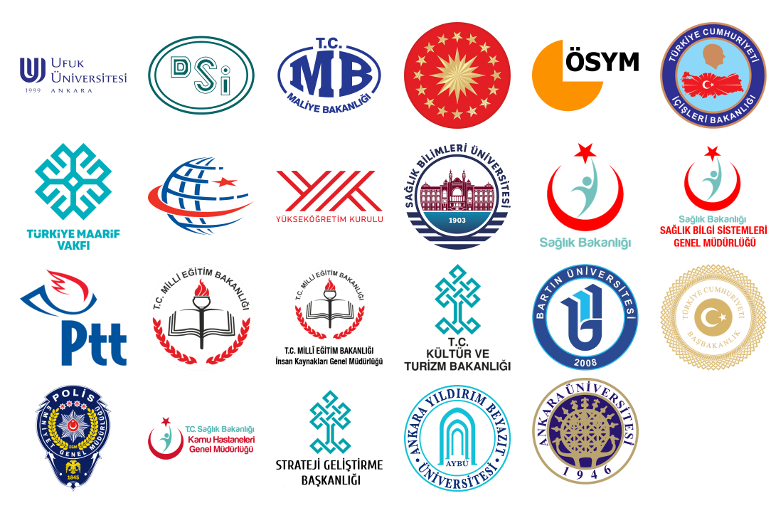

Figure 1: Reference and project examples of Fastsoft [1].

## Work Environment

I did my summer internship in the software department of the company. In the building I was in, there were adequately sized work areas. The part where I did my work was smaller and more intimate space. There were 5 people in my work area, including me. 3 of them were company employees, me and the other person were here for summer internship. Separate desks and work areas were given to each of us. We all had separate computers so we could do our tasks. I was free to use company computers. Since I don't have a portable computer of my own, I used company computers. In addition to these, we had areas where we could make tea and coffee for working or taking a break.

# Assigned Tasks and Projects

## Problem Definition

Generally speaking, I have not been given any major assignments nor I was involved in any of the company's projects by the managers. Since I did not receive any projects from my managers, I felt myself as assigned to my colleagues who were talented developers in the software department where I did my internship. Therefore, I asked them to guide me; what I should do, what the company focuses on in general, what programming languages and methods are used. So, with their help, I determined a work schedule for myself. In any case, the result I wanted to achieve during my internship was not to be under stress by being involved in projects or being assigned to time-limited tasks. Instead, I tried to learn the working methods and work life by getting close to my colleagues in my department, observing them, sometimes asking for help on the subject I focused on and sometimes examining the projects they were working on.

## Knowledge Integration

### Knowledge Integration with Course Work

As far as I learned, the projects were done in Microsoft Visual Studio in the company. Addition to that, C# was used frequently. Accordingly, I had to learn the basics of .NET because I had no experience with .NET before. Apart from that, in my tasks, when I needed to write code or read and understand a code, I mostly benefited from the CMPE 112 and CMPE 211 courses I took at school. If I had to explain the usefulness of these two courses in my studies as follows, since these courses are generally courses that explain the basics of programming, I could understand the destination of the code even if the code I read was from another programming language. To add, I did not have any problems with SQL writing/reading and SQL management, thanks to the CMPE 232 course, as projects related to management systems were mostly carried out in the company.

### Learned Tools and Technologies

First and foremost, I learned how to work with colleagues in work life. I have experienced in how I can adapt myself to my colleagues and work groups in my future working life. I observed in which areas programming can be used. In addition, if we consider the company I am in, I observed what kind of customer requests were received and what kind of projects were being worked on. Thus, I had an idea about what kind of projects I could work on in the future and what kind of customer portfolio I could serve. On top of that, I learned the basics of .NET and C# which are completely new topics to me. I learned basics of how to create website and design it. Such as Angular, HTML and CSS. However, I just studied and learn HTML and little bit CSS. Also, I revisited my SQL knowledge to understand and work on database purposes on company.

### Self-Learning

The self-learning part was very helpful to me. Because I learned the basics of technologies and structures used for projects in the company and tried to put them into practice. Since these technologies are not unique to only this company therefore, I have gained knowledge that I can use in my future work life. I used a lot of self-learning resources for the work plan I made with my developer colleagues. I used W3Schools [2], Codecademy [3], dotnet.microsoft.com [4], Stack Overflow [5], Udemy [6] that company provide me freely and YouTube [7] tutorials to make my research and studies.

## Work Plan and Timeline

|  |  |  |  |
| --- | --- | --- | --- |
| **Task** | **Start** | **End** | **Duration** |
| Task 1 | 24.08.2021 | 29.08.2021 | 1 week |
| Task 2 | 31.08.2021 | 05.09.2021 | 1 week |
| Task 3 | 06.09.2021 | 12.09.2021 | 1 week |
| Task 4 | 13.09.2021 | 19.09.2021 | 1 week |

Table 1: Tasks that I have gone over through my internship. Task explanation given below.

Task 1: Orientating to company and workspaces. Learning fundamentals of .NET and C#

Task 2: C# learning and how to use in problems

Task 3: SQL revisiting, how SQL used in company. C# learning, code implementation

Task 4: How to create a website and design it? Angular basics. HTML and CSS learning.

## Implementation

### Literature review and Data Collection

As I mentioned before, I used many resources on the internet to understand and implement my knowledge on my research and studies. Especially the fact that I was seeing the subjects I was working on for the first time created many difficulties for me. However, many written and visual resources I found on the internet made things easier for me to learn (see 3.2.3). It should not be forgotten that I was helped by my colleagues in matters that I did not understand and had difficulty in doing, and this provided me great ease.

### Implementation

As I stated earlier in my report, I did not receive any project from my managers or was not involved in any company project. Therefore, with the help of my co-workers, who are developers, I tried to learn the programming language and methods used by the company by myself. These were specifically .NET and C#. On top of that, I reviewed my SQL knowledge, learned HTML and a little bit of CSS for web design. The computers I worked on at my internship were not mine and I did not save all my work. Consequently, as an example, I will show the works that I can find on my devices and cloud storage.

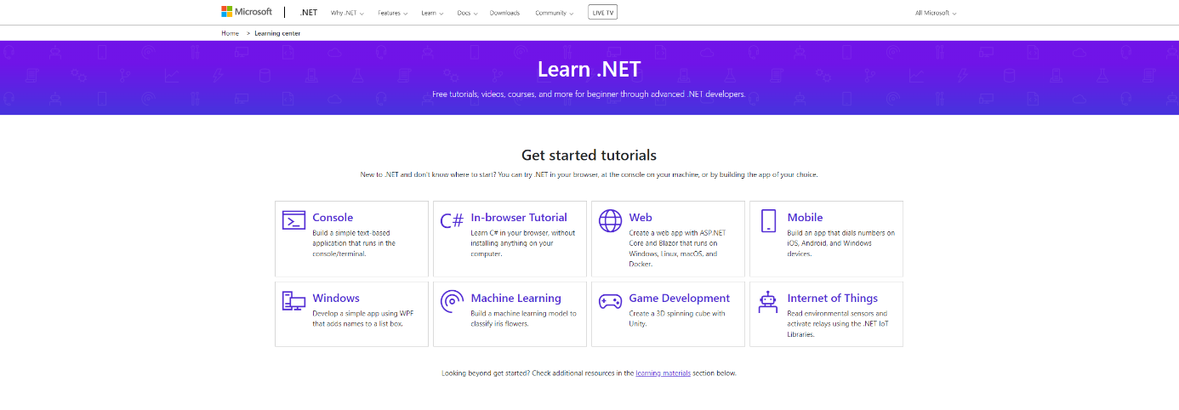Firstly, after learning the languages and methods used in the place I work, I did research on the internet to learn the basics of them.

Figure 2: The site where Microsoft's tutorials about the .NET framework and its many applications such as C# [7]

To work in C#, I first downloaded Visual Studio, which runs on Microsoft's .NET Framework.

metin içeren bir resim

Açıklama otomatik olarak oluşturuldu

Figure 3: Creating a new project on Visual Studio

Thus, I started learning C#, doing exercises and writing codes for questions and exercises I found on the internet. This allowed me to look and observe at the projects that my colleagues in the company were working on and to interpret these projects, as well as I learned to write in a new language.

metin içeren bir resim

Açıklama otomatik olarak oluşturulduFor instance, in “Figure 4”, I wrote a code that checks whether the sum of two numbers entered by the user is equals to 30. The program returns "True" if sum of them is equal to 30 and if not "False".

Figure 4: C# Program1

metin içeren bir resim

Açıklama otomatik olarak oluşturuldu

Figure 5: C# Program1's console execution

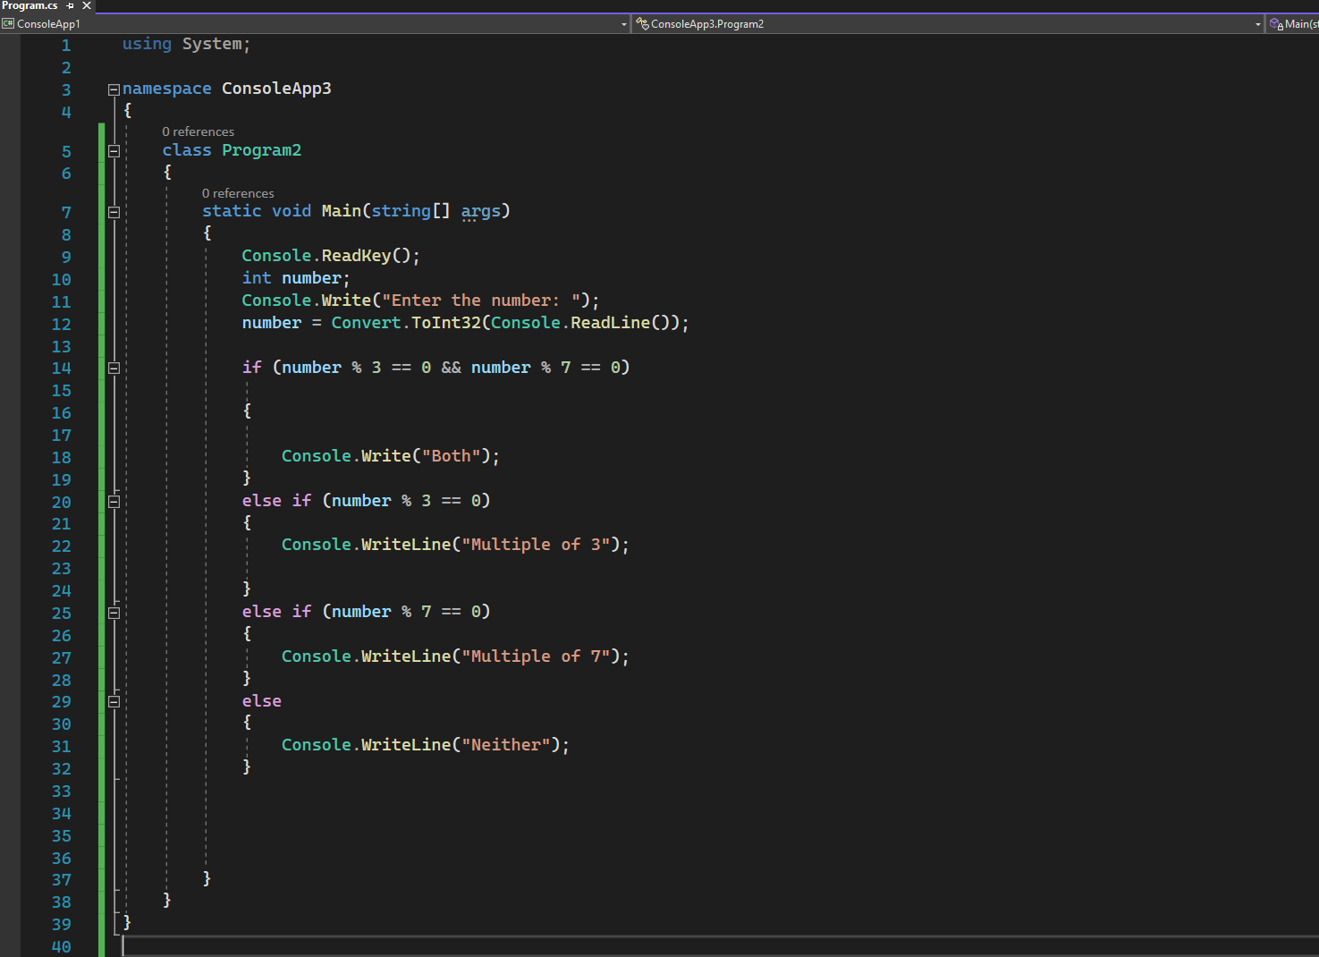Another example is in “Figure 6” I wrote a code that finds whether the number entered by the user is a multiple of 3 or a multiple of 7. The program finds whether the user's input is a multiple of 3 or 7, and prints “Multiple of 3”, “Multiple of 7” "Both" or if it's a multiple of both, and "Neither" if it's not a multiple of both.

Figure 6: C# Program2

metin içeren bir resim

Açıklama otomatik olarak oluşturuldu

Figure 7: C# Program2's console execution

Also, I had to review my SQL knowledge as the company usually writes and develops management applications. I handled this issue with resources on the internet and my notes from the CMPE 232 course I took the previous spring semester. When I came to the company, one of my colleagues was making a database-based program for an animal trading company. The program keeps information such as whether the animals bought and sold are crippled, animal’s age, weight, sex etc. I also went beside to my colleague from time to time and observed how he transferred his knowledge to the code and implemented the algorithms. While examining the codes, I tried to understand the codes he wrote by asking him where I did not understand.

Figure 8: Database Management Systems (DBMS) [8]

Apart from these, since I have an interest in web design, I consulted my colleagues and tried to learn HTML, CSS and Angular. Unfortunately, I couldn't learn Angular as Angular requires a lot of information beforehand. Using the information I learned, I designed the web page where I shared a short section of it in “Figure 9”. While making the page, I used HTML and CSS that I learned through my own research and work. This is the first time I've designed such a page, so it may not be exactly smooth. Besides, the page isn't complete because I stopped doing it when my internship was over. I used many features such as CSS designs, GIF background, clickable links on the page, but I added the source code and the page link to my report because it was not clear in the photo.

metin, iç mekan, kedi, ekran görüntüsü içeren bir resim

Açıklama otomatik olarak oluşturuldu

Figure 9: HTML page with CSS design

Source code and web page can be found at: <https://github.com/snckrkn/Erkan-Sancak-First-HTML-page.git>

metin içeren bir resim

Açıklama otomatik olarak oluşturuldu

metin içeren bir resim

Açıklama otomatik olarak oluşturuldu

Figure 10 and 11: Source codes of HTML page

## Evaluation & Impact Analysis

At the very end, I think that the research and studies I did during my summer internship had many effects on me. Learning to write in a new language is satisfying. Although I generally did less than I could do during my internship, I think that what I learned, what I experienced, especially my first experience of a workplace environment, and the research and work I did have a great impact on me. I especially found myself having fun working on SQL/DBMS and web design. Although HTML and CSS are not huge programming tools, they are very useful, and they are form the fundamentals. I realized that I am interested in these topics, and I hope to include Web Design and SQL/DBMS in my future studies and research.

# Conclusions & Recommendations

As a result, this internship has contributed a lot to me. Most importantly, I had the opportunity to work at a company for the first time. It helped me understand the how to work with groups and colleagues, importance of discipline and importance of work with groups and colleagues in a real company. On top of these, I had the opportunity to make useful use of my free time during the summertime.

When I first came to the company, I had a lot of stress and fear due to not being in a professional work environment before. However, these fears and my adaptation period were short-lived as my colleagues and superiors approached me with camaraderie and held me throughout internship. Thus, I achieved the goals I had in mind before I started my internship.

I can strongly recommend the company especially to people who are interested in or dealing with management systems and who are looking for a friendly and warm environment in their workplace.

# References

[1]: Reference and project examples of Fastsoft. <https://www.fastsoft.com.tr/referanslar/>

[2]: Online web tutorials for programming. <https://www.w3schools.com/>

[3]: Learning code online. <https://www.codecademy.com/>

[4]: Learning .NET and C# tutorials. <https://dotnet.microsoft.com/en-us/learn>

[5]: Question and answer site about computer programming. <https://stackoverflow.com/>

[6]: Online learning platform. <https://www.udemy.com/>

[7]: Video hosting website where programming tutorial can be found. <https://www.youtube.com/>

[8]: Figure 11: Database Management Systems taken from <https://medium.com/omarelgabrys-blog/database-database-options-part-10-380c6e4467d0>

[9]: Any other company information is taken from <https://www.fastsoft.com.tr/>

and <https://www.linkedin.com/company/fastsoftbilisim/>

[10]: Source code and web page can be found at: <https://github.com/snckrkn/Erkan-Sancak-First-HTML-page.git>